|  |  |  |
| --- | --- | --- |
| **LAB221 Assignment** | **Type:** | **Short Assignment** |
| **Code:** | **J2.S.P0015** |
| **LOC:** | **20** |
| **Slot(s):** | **1** |

**Title**

Simple menu

**Background Context**

Menu is important in desktop java application, it provide needed function for an application that users can easily work. MenuItem also has icon and short-cut.

**Program Specifications**

Create an application using java swing to create a frame look like (1).

**1. Main.java**

Make a frame look like description below.

***Function details:***

1. Display the GUI like figure (1).
2. When users select a menu item, display the name of corresponding menu.

***Expectation of User interface:***

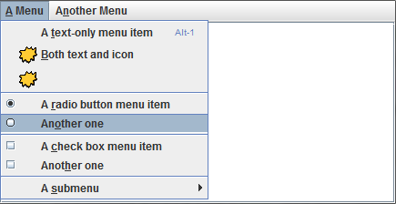 ***(1)***

**Guidelines**